HPG and Chaos Freerun clothing order form

Full Name: Total: £
 | Age  5-6 | Age  7-8 | Age  9-19 | Age  11-12 | Age  13+ | Adult  S | Adult  M | Adult  L
Crew neck t-shirt £15
Hoodie
Child £30
Adult £35

Please circle colour choice for hoodie and tshirt: RED BLACK
Personalisation £5 extra Write wording wanted here: ______________________

HPG gymnastics shorts

£12.00 | Age 4-5 years | 51/2- 7 years | 7-8 years | 9-10years
Black HPG Shorts
Personalisation

Leotard Order Form

Black HPG bodice leotard (all gymnasts) – upto chest size 36” £35

Red and black ombre training bodice Leotard –
(All Gymnasts) upto chest size 36” £45

Red and black ombre long sleeved Leotard - Competition upto chest size 36” £55

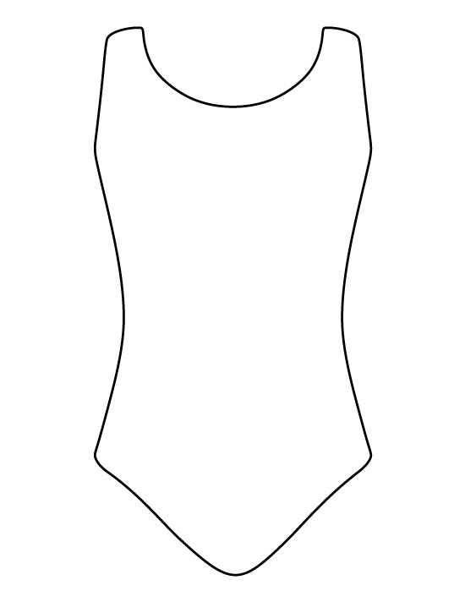
Chest measurement _________
Body measurement _________
Hip measurement ___________

Is any of this order a surprise? Yes No
If yes, please state which part:

Please check out our preloved rail with leotards of all different sizes, styles and colours.

